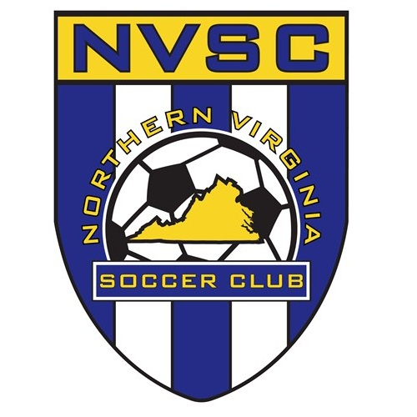
School name
Principal name
Street Address
City, State, Zip
Marie Schweitzer
Girls DOC, Northern Virginia Soccer Club
10103 Residency Road
Manassas, VA 20110
October 17, 2016
Dear Principal Name:
It is with great pride and honor that I announce student name, as a member of the Northern Virginia Soccer Club, has earned a berth in 2016 Super Y-League North American Soccer Finals. It is my intention with this letter to provide some background information on this extraordinary soccer opportunity.
The future of soccer lives in the United Soccer Leagues Super Y-League, a professionalized system that is the first step for developing elite youth soccer players in North America. Affiliated with U.S. Soccer the league is designed for talented youth players destined for professional or international careers. With the regular season running late spring into early autumn, the championship tournament is slated for early December to allow all geographic regions in the United States and Canada to compete.
This year's event will be held in Bradenton, Florida and will begin on Thursday, December 8th with the first day of matches being played on Friday, December 9th. Games are played each day through Monday, December 12th, with championship matches scheduled for Tuesday, December 13th. Please note that actual travel dates will be from date to date.
The event is sanctioned as a national Olympic Development Program of the United States Soccer Federation for identifying players for U.S. National Teams. Numerous professional and national level soccer players have participated in previous years championships, and the finals remain a highly attended event for collegiate recruitment.
As these players have demonstrated the character and athletic prowess to earn the right to represent Northern Virginia on this elite stage, our coaching staff, parents, and student players must remain committed to minimizing scholastic impacts. With your support and endorsement of the student athlete’s participation in this once-in-a-lifetime opportunity, the responsibility of any and all course work falls on the student and parents to ensure completion of all class requirements.
If you would like to learn more about this event and the opportunity given to these elite players, please visit the Super Y-League web site at www.uslsoccer.com or the specific North American Finals website at http://supery.uslsoccer.com/syl/sylfinals/

Sincerely,
Marie O. Schweitzer

Marie Schweitzer
Northern Virginia Soccer Club
www.novasc.org

